# Introduction

Global Traveler is a travel website which has its roots in my desire to become a travel blogger. However, instead of jumping to the blogging part of things, I decided instead to use it as an opportunity to practice full-stack development. Initially, I created the whole website using simple HTML, CSS and JavaScript, but I realized that it would be a tedious task to update the site. In addition, I also wanted to make sure that I could update the content dynamically so that I would not have to take down the site for every little update or iteration. Global Traveler was a concept for a while, and was only recently created before the beginning of CS499.

# Inclusion in CS499 ePortfolio

Global Traveler was the perfect candidate for my ePortfolio as it is a full-stack website. I could maintain the structure of the front and back ends and keep the website functioning in predominantly the same manner as its original state. I also wanted to progress to using a more relevant framework yet move on from the standard React JS that is popularly used today. Putting it together with Tailwind CSS and TypeScript, I created a codebase that is easily maintainable and workable when collaboration is concerned. This clearly shows my skills in full-stack software engineering and design through my understanding of feasible technologies and in creating a collaborative environment to work with.

# Meeting course objectives

For Enhancement One, I had aimed to meet course objectives:

1. (1) Employ strategies for building collaborative environments that enable diverse audiences to support organizational decision making in the field of computer science
   1. This was achieved through using GitHub and Git, which are both platforms for collaboration, in addition to the presence of clear comments that explain my process in my development. I also used clear naming conventions in naming my components so that any future developers who work on this project will be able to make the necessary edits.

Figure 1: File Structure

Figure 2: Commented code

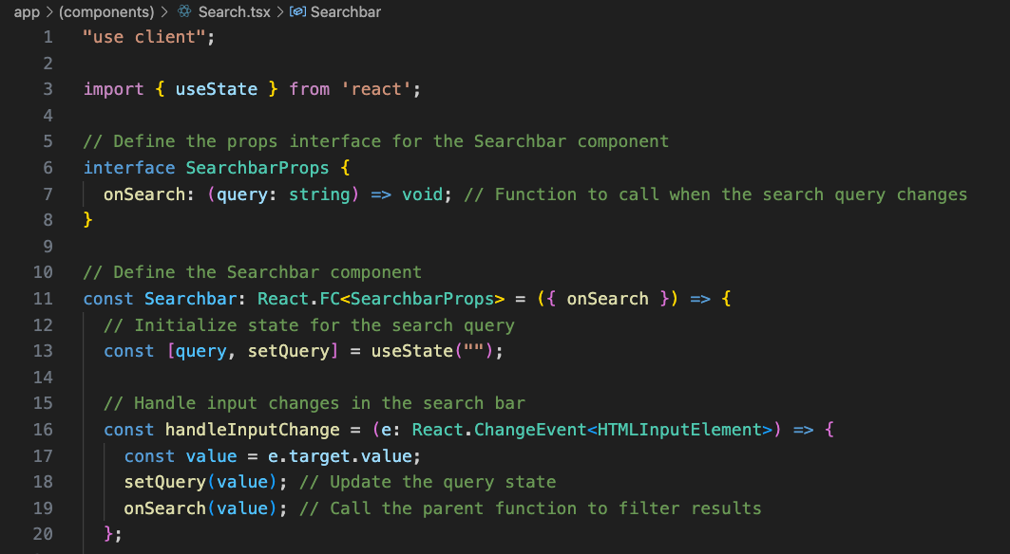

1. (2) Design, develop, and deliver professional-quality oral, written, and visual communications that are coherent, technically sound, and appropriately adapted to specific audiences and contexts.
   1. For the purposes of submission, I had to include the .env file, which, in the case of deployment, I would not do. I did, however, provide full instructions on how to run the code in the ReadME.
2. (4) Demonstrate an ability to use well-founded and innovative techniques, skills, and tools in computing practices for the purpose of implementing computer solutions that deliver value and accomplish industry-specific goals.
   1. I demonstrate this by choosing to use Next JS 14, Tailwind CSS and TypeScript, which are prevalent in today’s software engineering choice technologies. They are easy to use, easily maintainable and are long-lasting.

# Reflection

Executing this enhancement was not at all difficult, apart from the fact that I had to re-learn a few basics from what I knew about React.js. I did not try to re-create the whole site as is, however, I did include some minor changes that would have served well from a user experience and user interface point of view. I was very happy with how it turned out, and I look forward to continuing to work on this project for my new enhancements.